Rome and the Byzantine Empire
Chapter 17 notes (441-463)
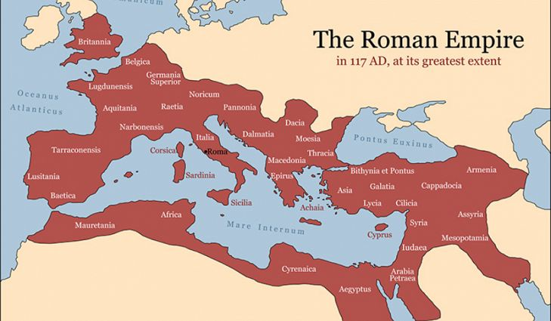
The Glory of Rome
- Founded c.700 BCE
- Strong Central Govt: Republic; Empire
- Powerful military: legions
- Technology: engineering, manufacturing
- Trade: Silk road
- Large and vast empire: (pop = 36-million)
- Becomes Christian under Constantine (4th century CE)

The Fall of Rome
- Rome falls in 476 CE to barbarians
- Western Europe enters the Middle Ages 500-1500 CE
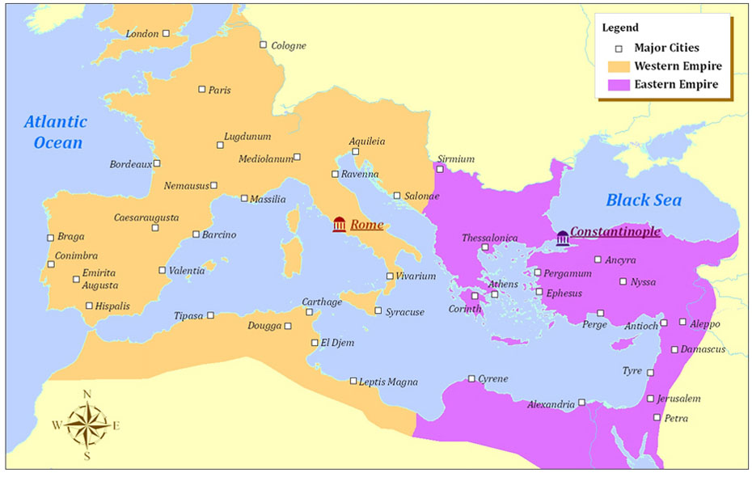
  - Sometimes referred to as the “Dark Ages” because much of Greco-Roman knowledge and culture was lost
- Rise of the manorial system (Feudalism): Serfs
  - Decentralized govt.
  - Interregional trade declines
- Western Europe vulnerable: Vikings, Muslims, Central Asian nomads

Eastern Roman Empire
- Survives after 476 CE as the “Byzantine Empire”
- Capital at Constantinople
- Great Schism 1054 CE: Eastern Orthodox Catholic church breaks from Roman Catholicism
- Interregional trade flourishes (Economic)
  - Eastern Europe – trade with the Rus and Slavs
  - Middle East – Silk road terminus

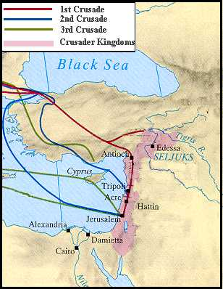
The Crusades
- Pope Urban II calls for Christians to take up the cross and reclaim the “Holy Land” – “God wills it!”
  - Motivations?
- Crusaders have some success
  - 200+years of Crusader Kingdoms in the Holy Land
- 4th Crusade sacks Constantinople
- Legacy
  - Exchange of ideas (access to Muslim libraries)
  - Greco-Roman knowledge returns to Europe = Renaissance
  - Military technology – castle architecture
  - Further division between Roman Catholicism and Eastern Orthodox Christianity
  - Prelude to the Reformation
  - Prelude to Colonialism
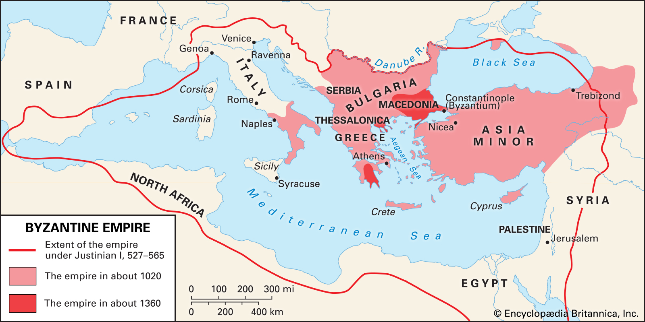

The Fall of Constantinople
- Shrinking borders
  - Muslims (Ottoman Turks)
  - Barbarians (Huns, Bulgars, Vikings)
  - Italian city-states (Venetians)
- Plague
- Byzantines never recover from sacking of Constantinople 1204 CE

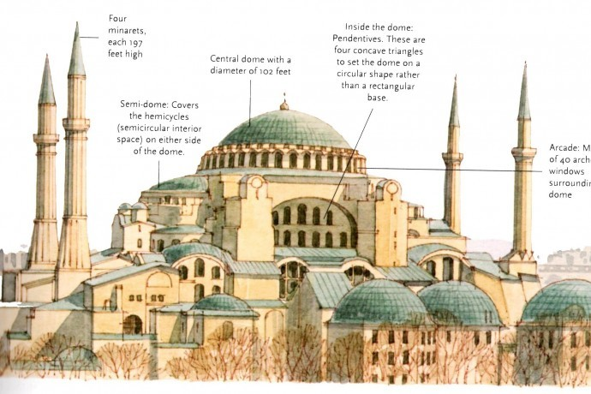
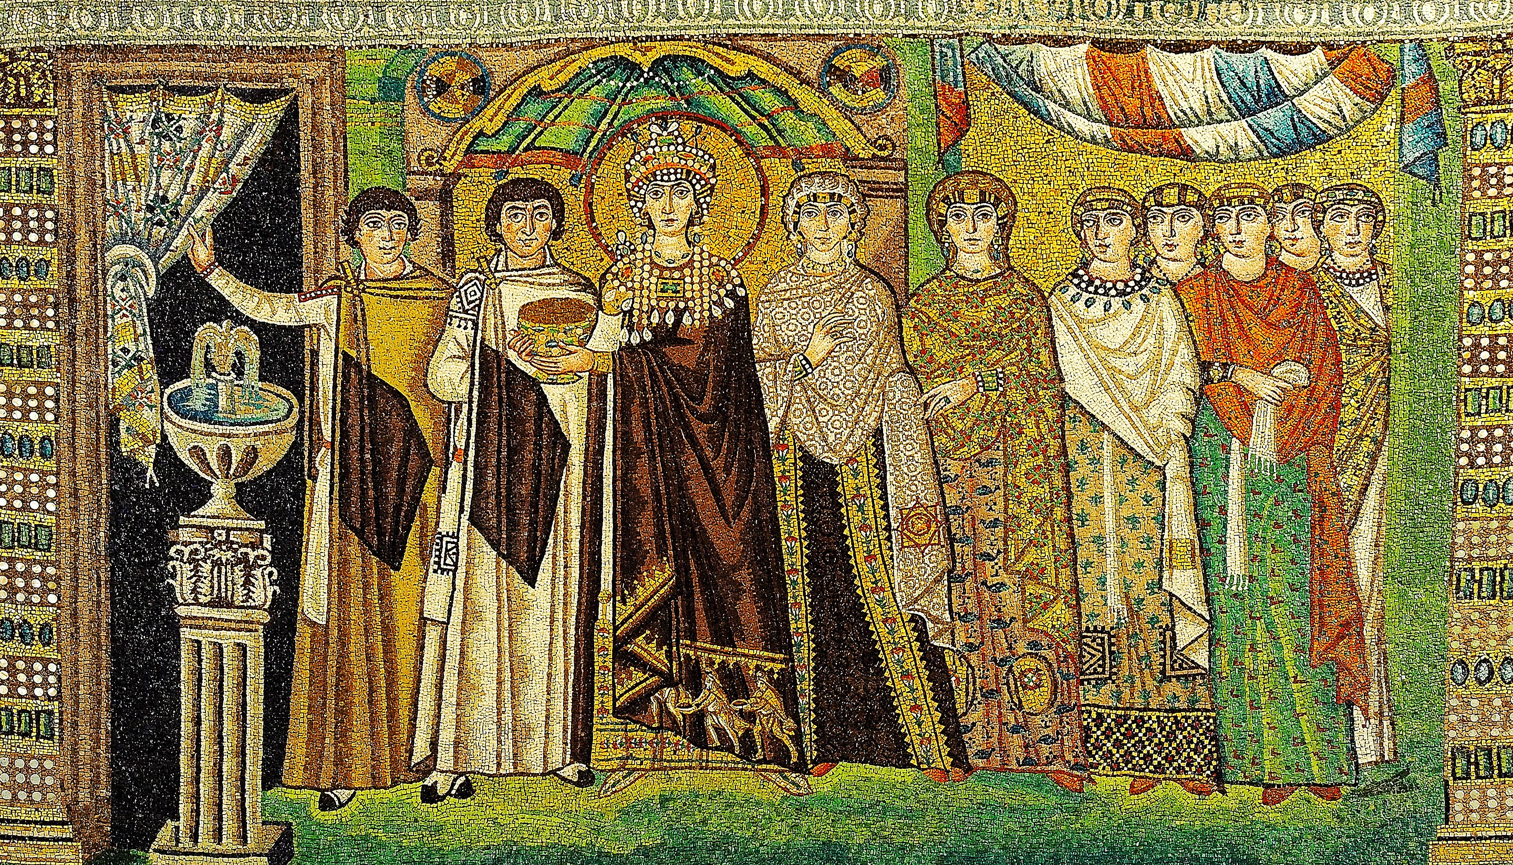
Byzantine Legacy
- Eastern Orthodox Christianity
- Preservation of Greco-Roman Knowledge
- Eastern Europe Influence
  - Culture: Cyrillic alphabet, religion, architecture
- Legal System: Justinian’s Code
- Shielded Western Europe (militarily)

