AP World History Themes – SEPTEC
Abv. | Theme | Explanation | Example
S | Social Interactions and Organization (SIO) | The process by which societies group their members and the norms that govern the interactions between these groups and between individuals influence political, economic, and cultural institutions and organization. | 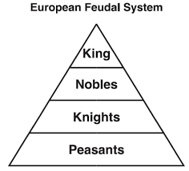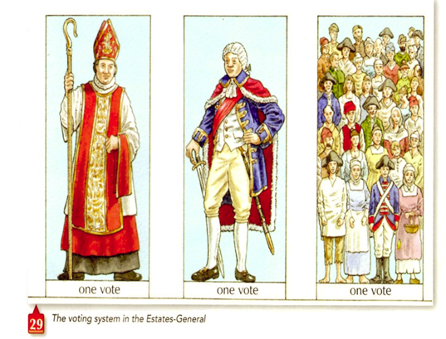
E | Humans and the Environment (ENV) | The environment shapes human societies, and as populations grow and change, these populations in turn shape their environments. | 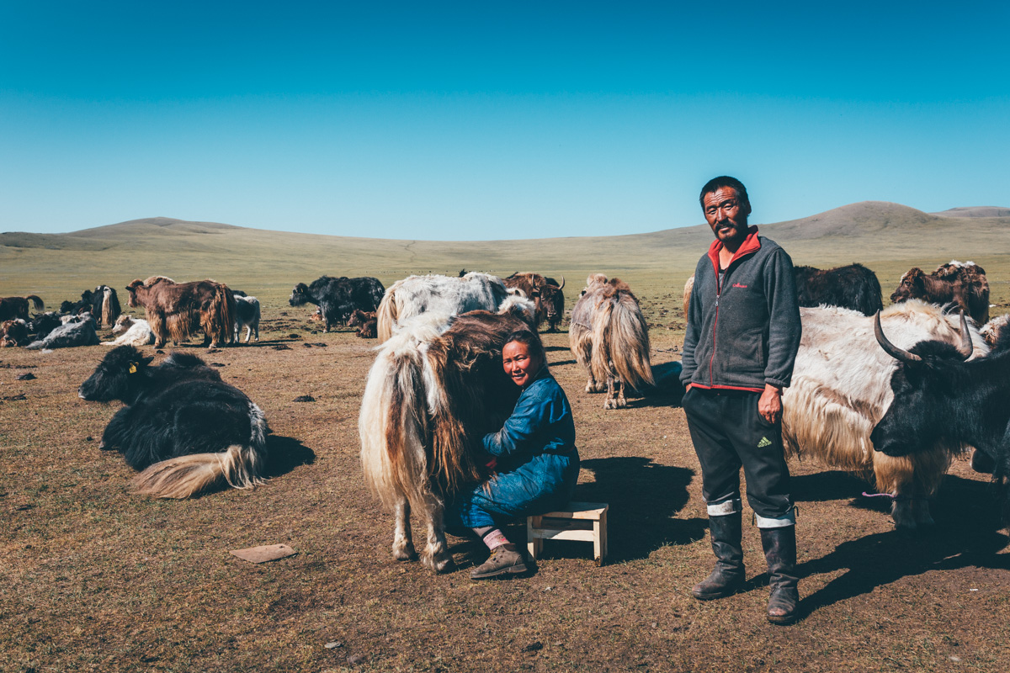
P | Governance/ political (GOV) | A variety of internal and external factors contribute to state formation, expansion, and decline. Governments maintain order through a variety of administrative institutions, policies, and procedures, and governments obtain, retain, and exercise power in different ways and for different purposes. | 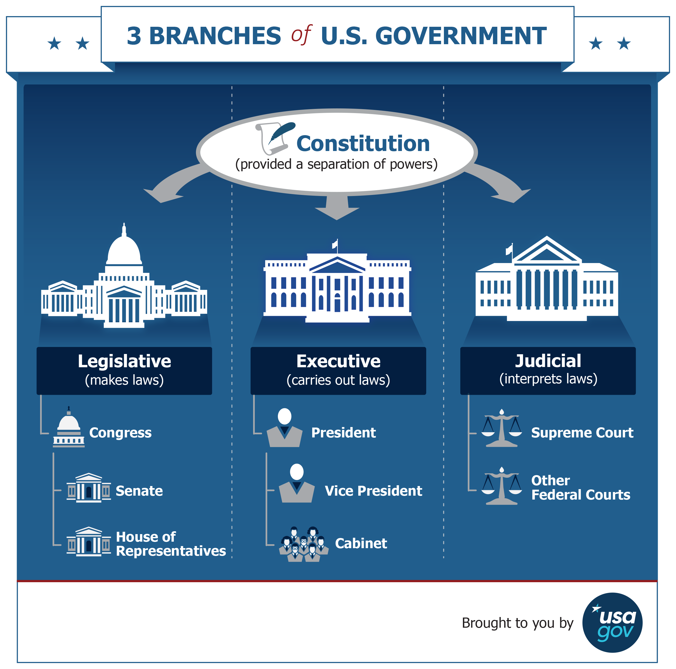
T | Technology and Innovation (TEC) | Human adaptation and innovation have resulted in increased efficiency, comfort, and security, and technological advances have shaped human development and interactions with both intended and unintended consequences. | 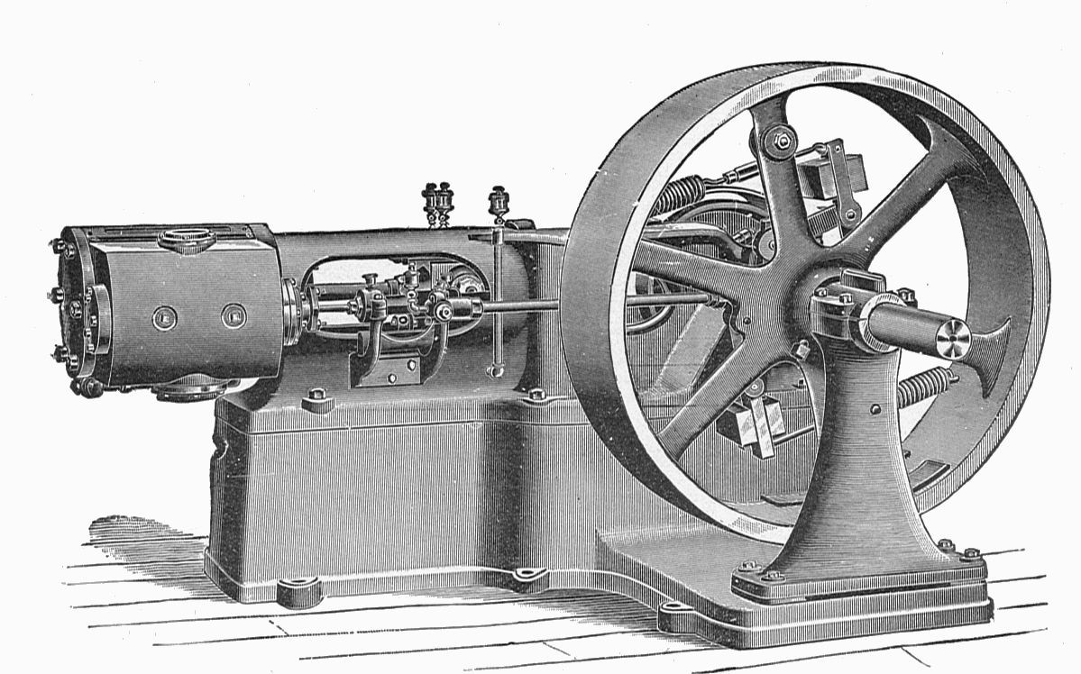
E | Economic Systems (ECN) | As societies develop, they affect and are affected by the ways that they produce, exchange, and consume goods and services. | 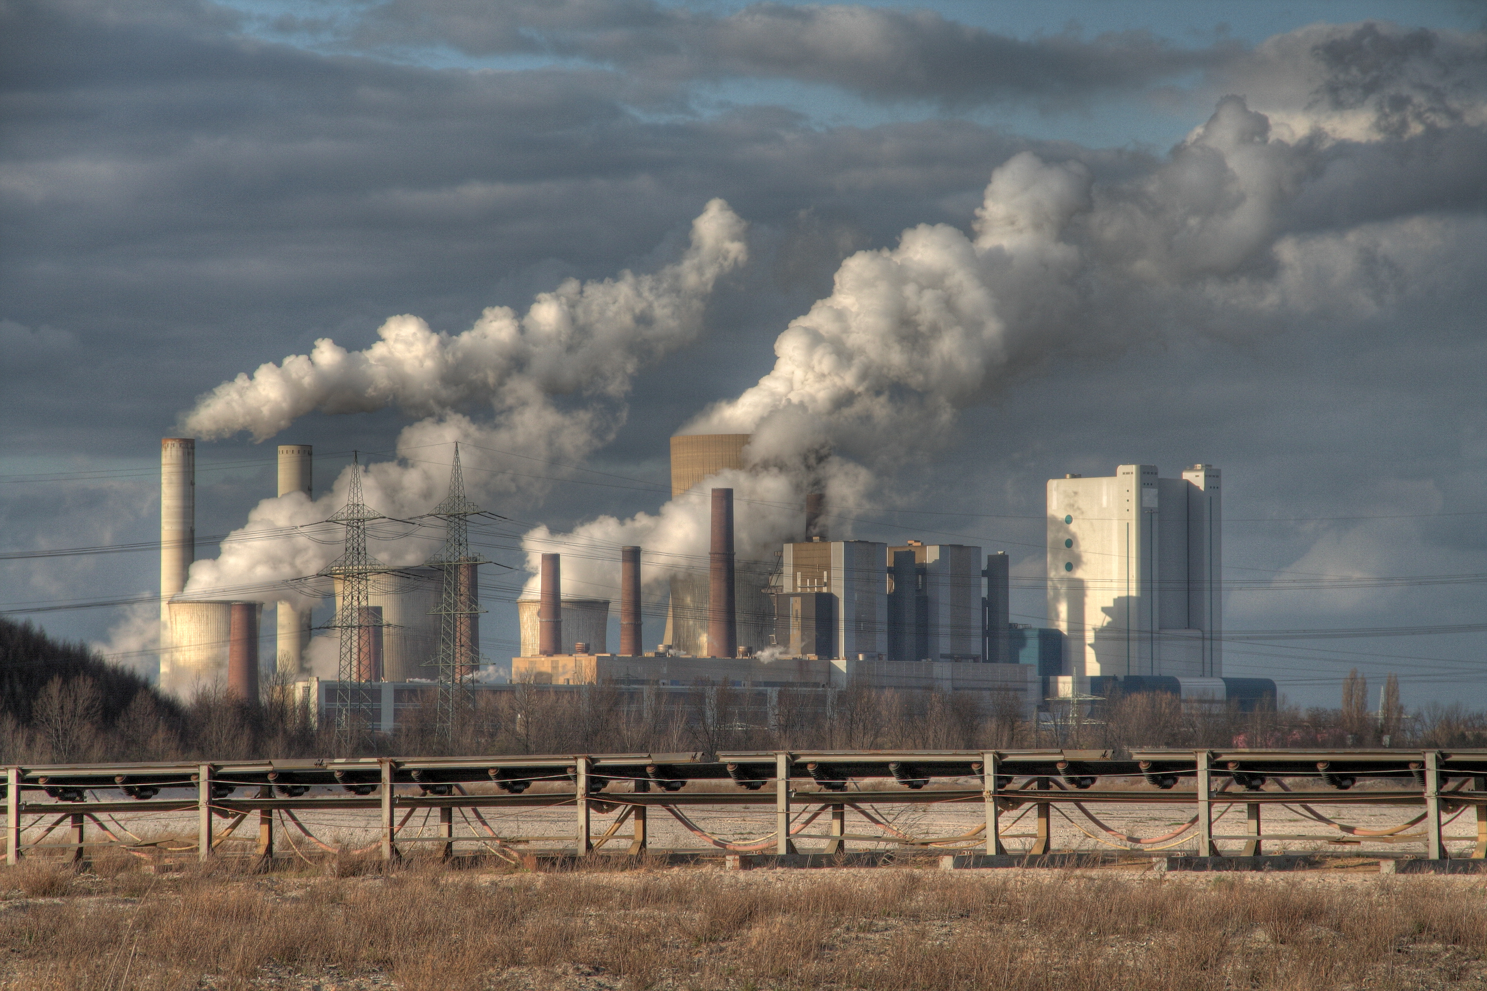
C | Cultural Developments and Interactions (CDI) | The development of ideas, beliefs, and religions illustrates how groups in society view themselves, and the interactions of societies and their beliefs often have political, social, and cultural implications. | 